Architectural Components - Service

📝Definition
# Source: AI Source: Provided by: [Data Path: Persons Table -> ID Column: 1, Name_En Column: Motasem Essam] -> From: [ChatGPT] on [1/23/2026]
The Service is a component responsible for handling business logic and orchestrating operations. It sits between Models/Repositories and Controllers/ViewModels.
👉 Think of Service as the brain of the application: it decides what to do with the data.

🔑 Responsibilities of Service
# Source: AI Source: Provided by: [Data Path: Persons Table -> ID Column: 1, Name_En Column: Motasem Essam] -> From: [ChatGPT] on [1/23/2026]
- Implement business rules and processes
- Orchestrate multiple models or repositories
- Keep Controllers/ViewModels thin and focused
- Serve as a unit for testing business logic

🧱 Example
# Source: AI Source: Provided by: [Data Path: Persons Table -> ID Column: 1, Name_En Column: Motasem Essam] -> From: [ChatGPT] on [1/23/2026]
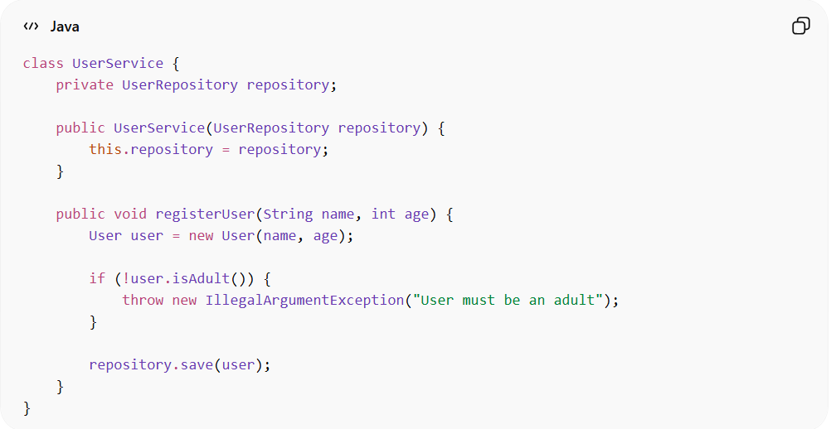
class UserService {
private UserRepository repository;

public UserService(UserRepository repository) {
this.repository = repository;
}

public void registerUser(String name, int age) {
User user = new User(name, age);

if (!user.isAdult()) {
throw new IllegalArgumentException("User must be an adult");
}

repository.save(user);
}
}
👉 Here:
- UserService contains business logic (age validation)
- Delegates data storage to the repository

❌ Bad Example (No Service Layer)
# Source: AI Source: Provided by: [Data Path: Persons Table -> ID Column: 1, Name_En Column: Motasem Essam] -> From: [ChatGPT] on [1/23/2026]
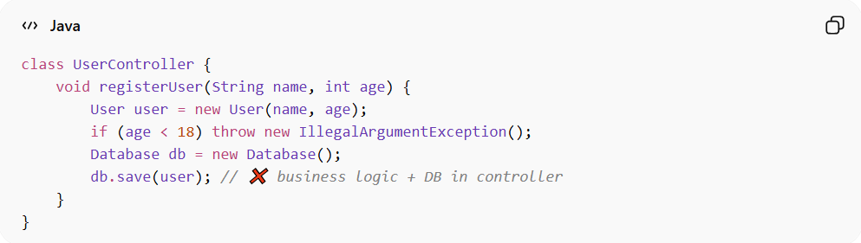
class UserController {
void registerUser(String name, int age) {
User user = new User(name, age);
if (age < 18) throw new IllegalArgumentException();
Database db = new Database();
db.save(user); // ❌ business logic + DB in controller
}
}
👉 Problems:
- Controller has too many responsibilities
- Hard to test business rules separately
- Violates Single Responsibility Principle (SRP)

✅ Good Example (With Service Layer)
# Source: AI Source: Provided by: [Data Path: Persons Table -> ID Column: 1, Name_En Column: Motasem Essam] -> From: [ChatGPT] on [1/23/2026]
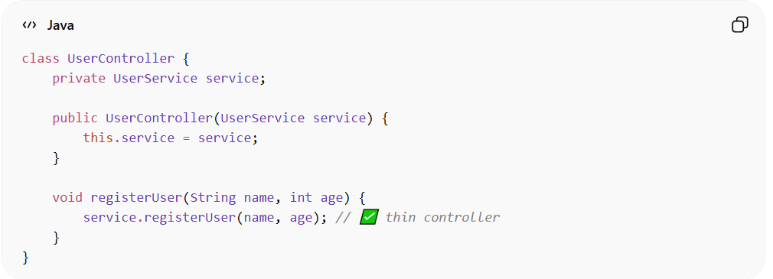
class UserController {
private UserService service;

public UserController(UserService service) {
this.service = service;
}

void registerUser(String name, int age) {
service.registerUser(name, age); // ✅ thin controller
}
}
👉 Benefits:
- Controller only handles input/output
- Business rules are centralized in Service
- Easy to unit test service independently

🔄 Service in Different Patterns
# Source: AI Source: Provided by: [Data Path: Persons Table -> ID Column: 1, Name_En Column: Motasem Essam] -> From: [ChatGPT] on [1/23/2026]
- MVC → Controller calls Service for business logic
- MVVM → ViewModel calls Service
- DDD → Services implement domain-level operations

⚠️ Common Mistakes
# Source: AI Source: Provided by: [Data Path: Persons Table -> ID Column: 1, Name_En Column: Motasem Essam] -> From: [ChatGPT] on [1/23/2026]
- Putting UI logic in Service ❌
- Accessing database directly from Service (without Repository) ❌
- Combining unrelated business operations ❌

💡 Key Idea
# Source: AI Source: Provided by: [Data Path: Persons Table -> ID Column: 1, Name_En Column: Motasem Essam] -> From: [ChatGPT] on [1/23/2026]
Service centralizes business logic, keeping UI and data layers clean and independent

🧾 Summary
# Source: AI Source: Provided by: [Data Path: Persons Table -> ID Column: 1, Name_En Column: Motasem Essam] -> From: [ChatGPT] on [1/23/2026]
Service:
- Handles business logic
- Orchestrates Models and Repositories
- Keeps Controllers/ViewModels thin
- Improves testability and maintainability

